THE TN SUMMER ACADEMY
SUMMER 2024

Please fill out the below form to register your child for
the TN Summer Academy 2024.
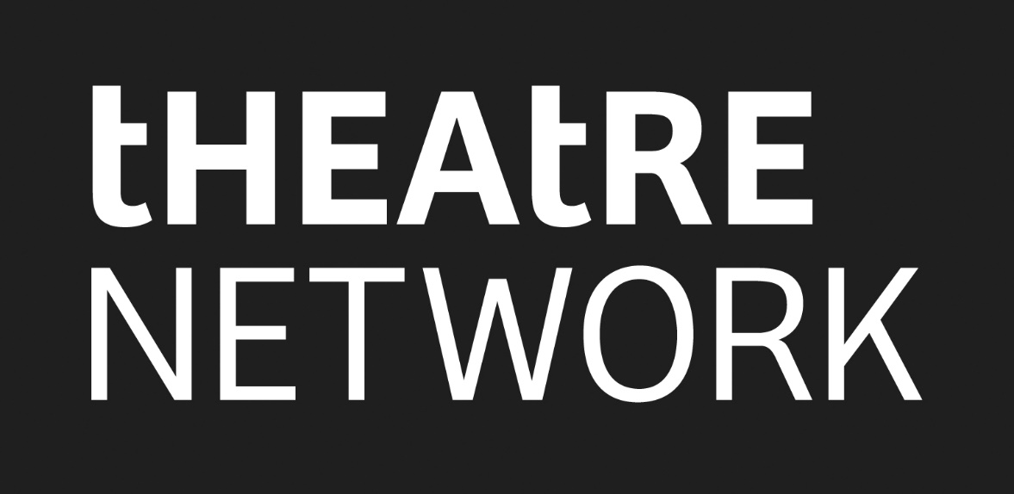

DATES
Four Week Rehearsal Process Monday, July 22- Friday, August 16, 2024 (9:00 am- 4:00 pm)

Fringe Performance Run Seven performances over the Festival (August 16 -25, 2024)

GENERAL INFORMATION
STUDENT NAME
STUDENT AGE

STUDENT BIRTH DATE

STUDENT ADDRESS

STUDENT PHONE NUMBER

STUDENT E-MAIL

PARENT NAME(S)

PARENT ADDRESS

PARENT PHONE NUMBER(S)

PARENT E-MAIL (S)

HEALTH INFORMATION
EMERGENCY CONTACT 1 (NAME) | PHONE NUMBER(S) | RELATIONSHIP TO STUDENT
EMERGENCY CONTACT 2 (NAME) | PHONE NUMBER(S) | RELATIONSHIP TO STUDENT
Does the Student have any physical health conditions? (please explain)

Does the Student have any mental or emotional health conditions? (please explain)

Does the Student take any medications that we should know about? (please explain)

Does the student carry their medication with them?

Is the student able to administer medication on their own?

Does the student need help administering their medication?
(please explain)

SAFETY / PICK UP INFORMATION
While at the theatre students will be supervised by an adult at all times, however; some parents/guardians like to allow their child to leave the building on breaks, lunch or at the end of the day.
Is the Student allowed to leave the theatre without supervision at the end of day?  (please circle and initial) | Yes / No | Parent Initial:
Is the Student allowed to leave the theatre without supervision at lunch time or on breaks?  (please circle and initial) | Yes / No | Parent Initial:
Please list the names of the people that have permission to pick up your child from the theatre camp.

MEDIA/ PHOTO RELEASE
Participation in the TN Summer Academy means that Theatre Network and the TN Summer Academy may take photographs of the student actors to be used to promote the show and future years of the program. These images may be used on the Theatre Network website and social media, TN Summer Academy website and social media and in print programs. The student’s name will also be listed in a program and on advertising for the performance such as posters and handbills.
Do you give permission for Theatre Network and the TN Summer Academy to take photos of your child and use photos for promotional purposes listed above?  (please circle and initial) | Yes / No | Parent Initial:
Do you give permission for Theatre Network and TN Summer Academy to print your child’s full name for promotional purposes listed above?  (please circle and initial) | Yes / No | Parent Initial:

CODE OF CONDUCT
Theatre Network and the TN Summer Academy are safe spaces which promote supportive and safe events free of homophobia, transphobia, racism, sexism, & discrimination.
At the TN Summer Academy, we do not allow:
- Abuse: including threats, attempts, and action that causes damage or harm or injury
- Violence: the use of intentional force to cause physical harm or injury to an individual, group or property
- Harassment: any comment, behaviour or act that are known or ought to be known as unwelcome by an individual or group as they are offensive, embarrassing, humiliating, demeaning, or unwelcome
- Threats: any act, gesture or language that insinuates or directly communicates the intended harm of another individual, group or property
- Discrimination: any comment, behaviour or act that is humiliating, offensive, traumatic, disparaging or otherwise diminish an individual or group’s dignity and/or well-being

If any of these unacceptable behaviours are witnessed and/or reported, it will result in an investigation and/or being asked to leave and/or no longer participate. At the discretion of The TN Summer Academy, the ability to return to the program again will be based on the severity of the incident.

All participants involved in the activities of the TN Summer Academy, will adhere to agreed code of conduct.
STUDENT NAME | STUDENT SIGNATURE | DATE
PARENT/ GUARDIAN NAME | PARENT/ GUARDIAN SIGNATURE | DATE

REHEARSALS
Please see below our rehearsal schedule for the TN Summer Academy. Please fill out the dates/times your student will not be present.
WEEK ONE | Monday, July 22- Friday, July 26  9:00 am- 4:00 pm | Please list any dates/times within this week that your student will not be present.
WEEK TWO | Monday, July 29-  Friday, August 2  9:00 am- 4:00 pm | Please list any dates/times within this week that your student will not be present.
WEEK THREE | Tuesday, August 6-  Friday, August 9  9:00 am- 4:00 pm | Please list any dates/times within this week that your student will not be present.  Please note we will take Monday, August 5 off for the Civil holiday.
WEEK FOUR | Monday, August 12-Friday, August 16  9:00 am- 4:00 pm | Please list any dates/times within this week that your student will not be present.
PERFORMANCE RUN | Friday, August 16- Sunday, August 25  TIMES TBA  Students are not required to attend all day, however, they will be required to be present at the theatre an hour before their performance. | Students must be present for all performances, however if you know of any date that they would be unable to perform we can request that we don’t have a performance that day.

PAYMENT INFORMATION
TN Summer Academy Tuition | $1,250.00
 | TOTAL

PAID BY (please circle): CREDIT CARD CHEQUE

To pay by Credit Card, please call Theatre Network at (780) 453-2440
To pay by Cheque, please send in this registration form to:
THEATRE NETWORK
10708 124 St, Edmonton, AB T5M 0H1

Cheques should be made out to: THEATRE NETWORK

ADDITONAL INFORMATION
Is this any other information that you would like to the leader of program, Ellen Chorley to know?
If so please write it here (or email to Ellen Chorley at ellenchorley@hotmail.com)

